# Implementation of data structures to prevent collisions of robotic bees

|  |  |  |
| --- | --- | --- |
| **Jose Villamizar**  Universidad Eafit  Colombia javillamip@eafit.edu.co | **Kevin Gutierrez**  Universidad Eafit  Colombia kgutierreg@eafit.edu.co | **Jhesid Suarez**  Universidad Eafit  Colombia jssuarezb@eafit.edu.co |

# ABSTRACT

Using drones to pollinate flowers in respond to the decrease of honeybees is a great idea, but it also has a big problem, when handling multiple drones there is a risk, which is of them colliding or crashing, this poses a great risk to the drone’s solution because that can damage or even poll destroy the drones.

**Keywords**

Collision detection, QuadTree, drones automatization, data structures.

**ACM´s keywords**

# INTRODUCTION

For the past eleven years there has been a quite problematic situation all around the world, there has been a large decrease in the number of honeybees and wild bees in general, with many reports of beekeepers worldwide stating that thousands of hives were empty out of nowhere, this raised many concerns about what was going to happen with the honey industry, but most importantly about the pollination in the world, given the fact that bees are responsible for the pollination of the flowers, which are very important to our economy, in order to solve it many options were proposed, including one that wants to use drones for pollination purposes, calling them robotic bees because of the function that they fulfilled .

# PROBLEM

The clever solution that we discussed in the previous point, had a really big problem, which is that when handling many “bees” (Which is the idea of this solution) the bees had no form of detecting and avoiding each other, which led to they colliding and running into each other, this is a big deal because this slows down and even debilitates this solution to the global pollination problem, and this is the best solution so far, if it does not work we will be in serious problems according to BBC if we lost bees (and had no other way to pollinate) : “*We would lose all the plants that bees pollinate, all of the animals that eat those plants and so on up the food chain. Which means a world without bees could struggle to sustain the global human population of 7 billion. Our supermarkets would have half the amount of fruit and vegetables*.”

# RELATED WORK

## Quad tree

The quad tree is often used when trying to look for something on a 2D plane.

A plane is divided in four parts, each part represents the branch of the quad tree, in the case that in one of the divisions there is an object the area is divided again into four parts which will leave us with four other branches of the tree, but if there Is not an object in that branch it becomes a leave of the tree with this method you can recognize whether there are to colliding objects if they are on the same branch or area.

## Octa tree

The octa tree is often used when trying to look for something on a 3D plane.

The octree takes a 3D plane and divides it into eight areas, this way every area represents a branch of the octatree, if there is an object within one of these areas, another eight branches will be formed from the area that the object was found in, this way the leaves of the tree are areas where no object has been found, the eight divisions instead of the four used in the QuadTree makes these method more suitable for a 3D plane instead of a 2D one.

**3.3 AABB (Axis-aligned bounding box)** This method consists in surrounding the objects you want to track with common geometrical shapes, this makes it way easier to track the objects using low resource mathematical methods, and makes it way easier and effective to track the collision of two or many objects in a 2D 3D or ND plane, tho it is very easy to understand and is very memory-efficient it is not very precise at a pixel level, so it is usually used as a test method and when it shows a collision a more precise method is called.

**3.4 Hierarchical Structures Based on Spheres** To detect the collision between 2 objects, the objects are covered over all their surfaces with balls, this is done with the objective of detecting a possible collision, to make this possible, at the moment that a ball from an object has contact with a ball of another object, the distance between the centers of both spheres is calculated , in this way, if the distance is bigger than the radius of the smallest sphere, this means that a collision has happen.

**4. QUADTREE**

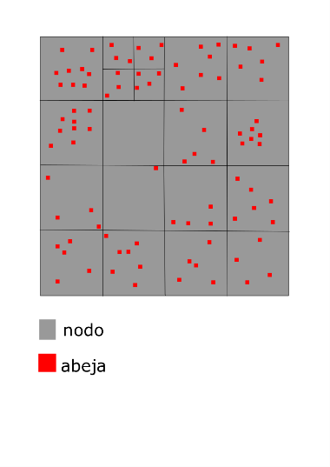

**Graph 1:** quadtree encharged to stock the data of the “bees” taking into account the coordinates provided, each time a node is filled to his limit, thisone is sub-divided onto 4 more nodes.

**4.2 DATA STRUCTURE OPERATIONS**

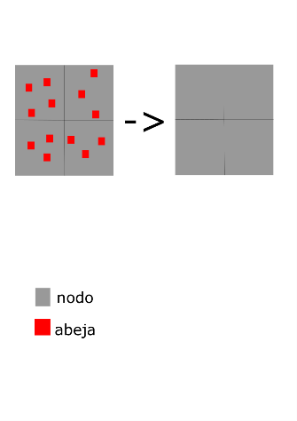

**Graph 2:** the clear function takes all the “bees” from each node and deletes them

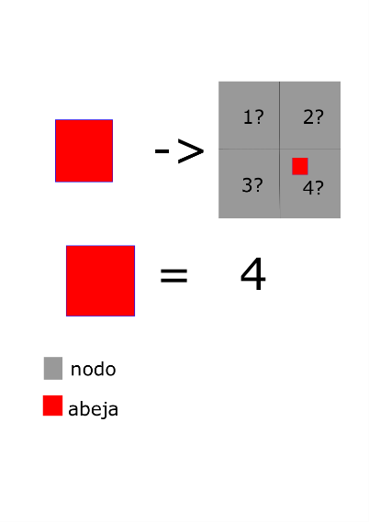

**Graph 3:** the function get index returns the node where an specific “bee” is located, on this example on the node °4-

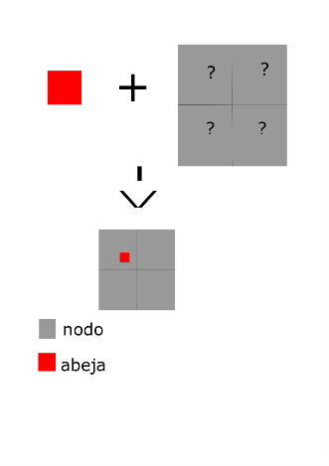

**Graph 4:** the function insert puts the “bee” on a node based on the given information(coordinates).

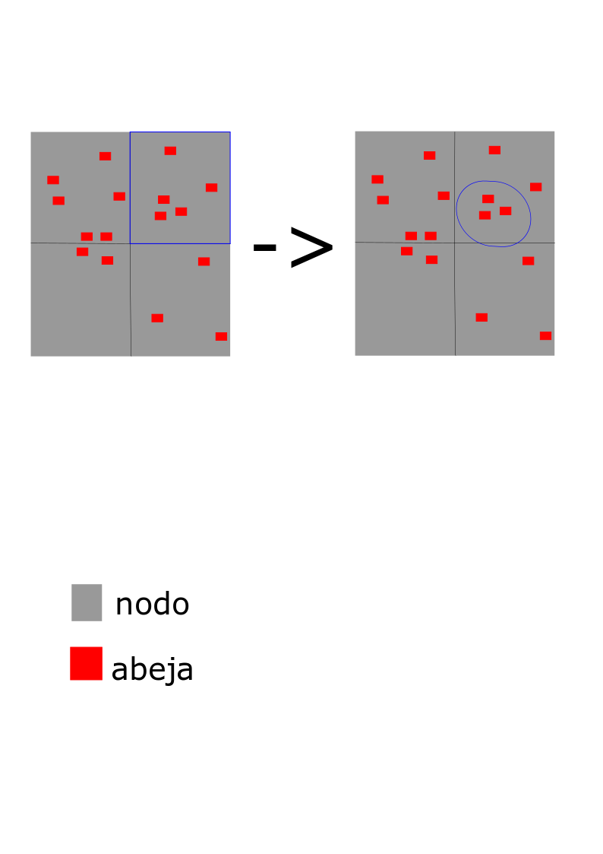

**Graph 5:** the retrieve function throws all the collisions that are detected on a specific node

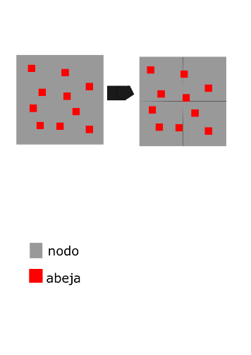

**Graph 6:** the split function divides a node on 4 nodes when the original node reaches his limit, also it takes all the “bees” on the initial node and insert this ones on the node that will be in charge of his store.

**4.2 DATA STRUCTURE DESING CRITERION**

we desing this data structure using the algorithm "quadtree", this algorithm is eficient in the solution of the 2D collision problems, the eficiency of this algorithm comes from is capacity to reduce the probable cases on a big way, leaving to us a really small number of cases to test, and that means a short time of execution

# REFERENCES

1. [http://theconversation.com/ten-years-after-thecrisis-what-is-happening-to-the-worlds-bees77164](http://theconversation.com/ten-years-after-the-crisis-what-is-happening-to-the-worlds-bees-77164)

1. BBC: WHAT WOULD HAPPEN IF BEES WENT EXCTINCT? (4/5/2014)

http://www.bbc.com/future/story/20140502what-if-bees-went-extinct

1. WHAT IS ABB COLLISION DETECTION

19/3/2014

https://stackoverflow.com/questions/22512319/w hat-is-aabb-collision-detection

1. ALGORITMOS DE DETECCION DE COLISION BASADOS EN ESTRUCTURAS

(2018) http://catarina.udlap.mx/u_dl_a/tales/documentos

/msp/ramirez_o_md/capitulo2.pdf

1. Jorge Rodriguez MATH FOR GAME DEVELOPERS - BULLET COLLISION (VECTOR/AABB INTERSECTION)

(21/3/2013)

1. [https://www.youtube.com/watch?v=USjbg5QXk 3g](https://www.youtube.com/watch?v=USjbg5QXk3g)
2. ALGORITMOS DE DETECCION DE COLISION BASADOS EN ESTRUCTURAS

JERARQUICAS (2018)

[http://catarina.udlap.mx/u_dl_a/tales/documentos](http://catarina.udlap.mx/u_dl_a/tales/documentos/msp/ramirez_o_md/capitulo2.pdf)

[/msp/ramirez_o_md/capitulo2.pdf](http://catarina.udlap.mx/u_dl_a/tales/documentos/msp/ramirez_o_md/capitulo2.pdf)

1. QUADTREE (2018) <https://en.wikipedia.org/wiki/Quadtree>
2. OCTREE (2018) <https://en.wikipedia.org/wiki/Octree>
3. Steven Lambert (2012) QuadTree java source code (version 1.0) [source code]. https://gamedevelopment.tutsplus.com/tutorials/quick-tip-use-quadtrees-to-detect-likely-collisions-in-2d-space--gamedev-374